

Installing the Tiger Printer Driver Locally
Note:
- Prior to installing this printer driver please remove any old version of the driver you may have before continuing with the install. For instructions on how to uninstall your old driver please refer to the troubleshooting section.

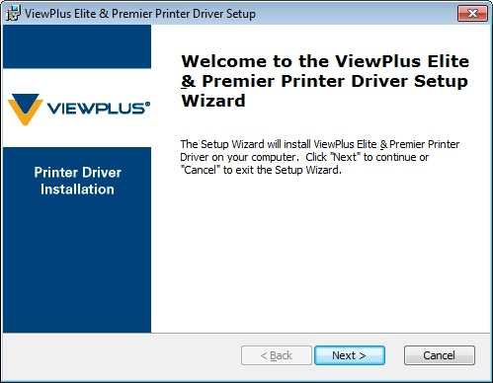
- Do not plug in the embosser to power before you are instructed to do so. If you have already connected the power cable to the printer and an outlet, disconnect it before beginning the driver installation process.

To install the embosser locally:
1) Connect a USB cable from the printer's USB port to your computer's USB port.
2) Double-click the exe file to run it.
3 On the first installation screen, select "Next" to begin the installation process.

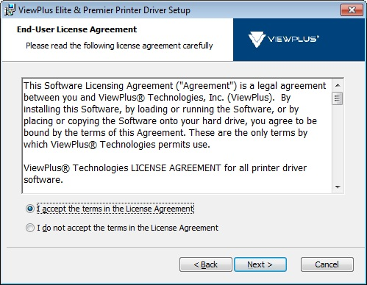

4) A user license agreement is displayed. To continue with installation, you must accept the terms of the license agreement and select "Next".

5) Select "Install" on the next screen to install the driver.
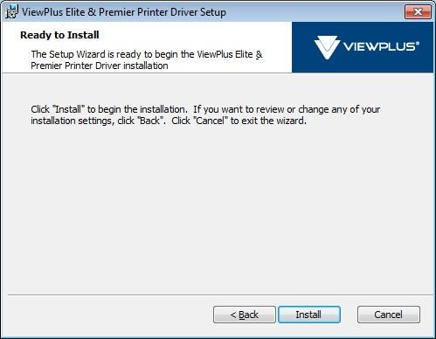
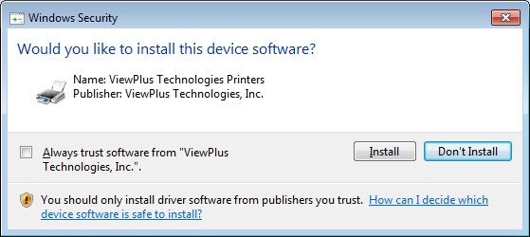
6a) Windows Vista or Windows 7: A dialog may pop up asking you if you would like to install device software from ViewPlus Technologies. Choose "Install".

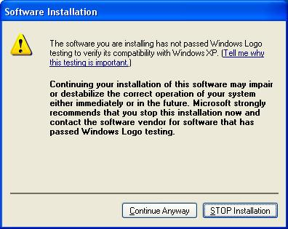

6b) Windows XP: A dialog may pop up informing you that the software has not passed Windows Logo testing. Select "Continue Anyway".

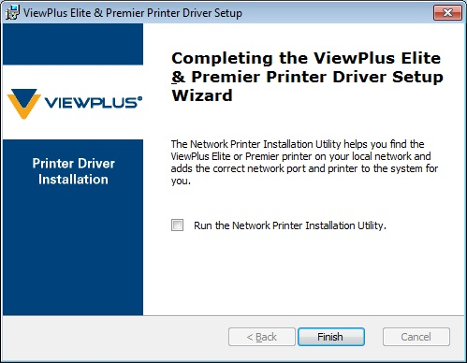

7) You will be presented with an option to run the Network Printer Installation Utility. Leave this box unchecked and select "Finish".

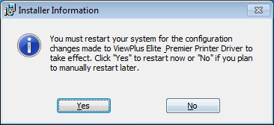

8) A dialog will appear asking you to restart your computer. Select "Yes" to restart immediately or select "No" if you plan to restart manually later.
Select "YES" for XP only. VISTA and W7 users should wait to restart until the following steps are completed and select "NO" at this dialogue.

9) Plug in a power cable to the embosser and to an outlet. Turn the embosser on.
10a) Windows Vista or Windows 7: The driver installation will complete automatically.

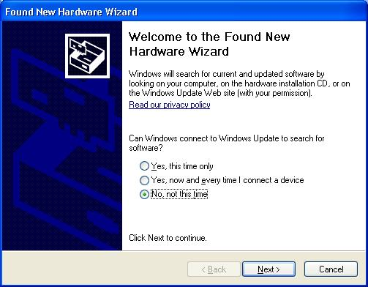

10b) Windows XP: The "New Hardware Wizard" will come up. On the first screen, which asks whether to connect to Windows Update to look for a driver, select the "No, not this time" radio button and then choose "Next".

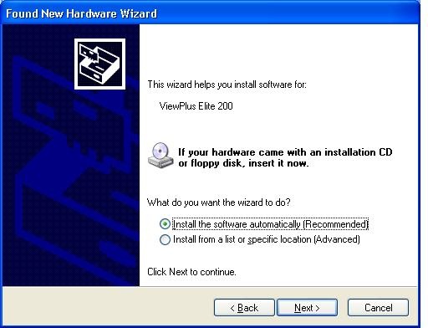

On the second screen, select the "Install the software automatically (Recommended)" radio button and then choose "Next".

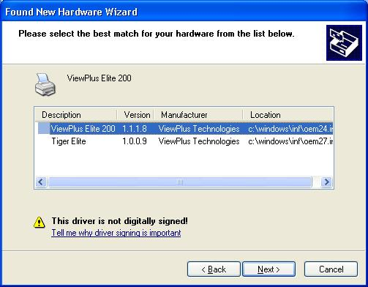

On the third screen, select the newest driver in the list and then choose "Next".

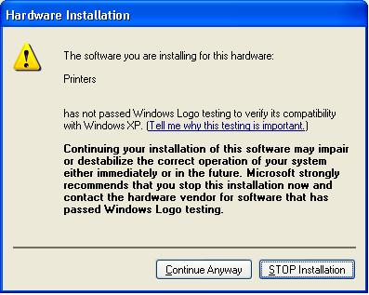

You may receive the dialog about Windows Logo testing again; if so, choose "Continue Anyway".

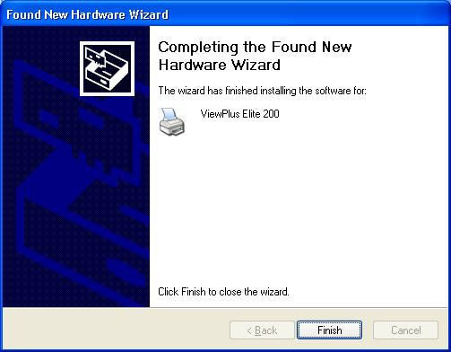
The driver will finish installing and present an installation finished screen. Choose "Finish".

If you did not restart before, you should do so now or after installing your Tiger Software Suite software.

Troubleshooting
To remove previous versions of Tiger printer drivers released after August 31, 2010:
1) From the Windows Start menu Programs list, select the ViewPlus folder. Select the printer driver and choose "Uninstall" from the drop-down menu.

To remove previous versions of Tiger printer drivers released prior to August 31, 2010:
1) Navigate to http://downloads.viewplus.com/drivers/tiger-clean-up/.
2) Download the Tiger Clean Up file.
3) Run Tiger Clean Up.
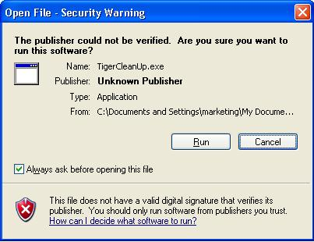
4) A dialog box will pop up informing you that this utility will remove old Tiger and ViewPlus embosser files from the computer. Choose "OK".
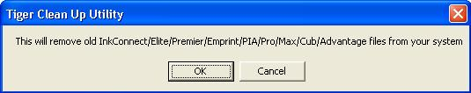

5) When the files have been deleted, another dialog box will pop up informing you that the files have been removed. Choose "OK".
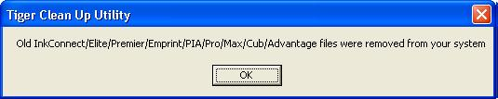
6) From the Windows Start menu Programs list, select the ViewPlus folder. If the printer driver appears in this list, select it and choose "Uninstall" from the drop-down menu.
7) Restart the computer.

If you encounter an error installing the embosser:
1) Make sure that the embosser is connected by USB for local installs or to the network for network installs, and that you are turning on the embosser when instructed to do so.
2) Try removing previous drivers, restarting the computer and installing again according to the directions above.

If you need to contact technical support, please provide the following information:
1) The embosser model
2) The embosser serial number, located on a sticker on the back of the embosser
3) The method by which you are attempting to install the embosser (USB, network)
4) The operating system on the computer on which you are trying to install (Windows XP, Vista and 7 are supported)
5) A detailed description of the problem
ViewPlus technical support is available online at http://www.viewplus.com/contacts/contact-support/, by email at support@viewplus.com or by phone at 866.836.2184

